Wells Dam Overshoot Reduces Natal Return Probability
in Wild Entiat River Steelhead:
A PIT-Tag Analysis Using Bayesian Hierarchical Methods

Prepared by:

Public Utility District No. 1 of Douglas County
East Wenatchee, Washington

April 2026

Abstract
Wild summer steelhead (Oncorhynchus mykiss) returning to the Entiat River have been observed overshooting their natal tributary and ascending the fish ladders at Wells Dam (river kilometer 830). Whether this overshoot behavior reduces subsequent probability of return to the Entiat River subbasin has not been formally evaluated. Using PIT-tag detection data from 379 wild Entiat-origin steelhead detected above Rocky Reach Dam across return years 2004–2025, we employed Bayesian hierarchical logistic regression to test whether interaction with Wells Dam, harvest status (open vs. closed years), spring return timing, and spill conditions at Wells Dam predict whether a fish is subsequently detected in the Entiat River subbasin. Fish were classified into Group A (no Wells Dam detection post-adult Rocky Reach passage; n = 239) and Group B (Wells Dam interaction, excluding confirmed strays; n = 140). Group A fish were detected in the Entiat River 73.2% of the time compared to 58.6% for Group B—a 14.6 percentage-point gap. The Bayesian hierarchical model estimated an odds ratio of 0.53 (95% HDI: 0.34–0.81) for the Wells Dam interaction, with posterior probability of a negative effect of 0.997. This result was robust to inclusion of a spring return season covariate, which itself showed no credible effect (OR = 0.98), ruling out lower spring detection efficiency at Entiat antennas as a confounding explanation. A compound-detection-likelihood model incorporating per-fish ENL detection efficiency (Y ∼ Bernoulli(θ × p_ENL); mean p_ENL = 0.86) yielded a stronger estimate (OR = 0.45; 95% CI: 0.26–0.77; P(β < 0) = 0.998), and a hidden stray analysis estimated fewer than three undetected strays among 53 undetected Group B fish, confirming the effect is not attributable to imperfect detection or hidden straying. Among Group B fish (Model 2; n = 116 with spill data), neither spring nor fall spill hours at Wells Dam nor harvest status predicted Entiat return. These findings indicate that wild Entiat steelhead that overshoot to Wells Dam have roughly half the odds of being detected returning to the Entiat River, an effect consistent across dam operating conditions and seasons, with direct implications for ESA recovery planning.

Keywords: steelhead, overshoot, natal homing, PIT tag, Bayesian hierarchical model, Wells Dam, Entiat River, Columbia River

Introduction

Conservation Significance
Upper Columbia River steelhead are listed as threatened under the Endangered Species Act (ESA), having been originally listed as endangered in 1997 and reclassified to threatened in 2006 (NOAA Fisheries 2024). The Entiat River supports a genetically distinct wild steelhead population within this distinct population segment (DPS). Wells Dam, owned and operated by Public Utility District No. 1 of Douglas County, is located on the mainstem Columbia River approximately 31 river miles upstream of the Entiat River confluence and is the uppermost dam with fish passage facilities on the mainstem Columbia. Any Entiat-origin fish detected at Wells Dam has already passed its natal tributary confluence, making detection there definitionally an overshoot event. Understanding what proportion of these overshoot fish successfully return to the Entiat River—and what factors influence that probability—is directly relevant to recovery planning and hydroelectric project licensing under the Wells Habitat Conservation Plan and Anadromous Fish Agreement.

Steelhead Overshoot Behavior
Most anadromous salmonids exhibit strong natal homing fidelity, returning to their birth streams to spawn following a marine phase. However, "overshooting" occurs when adult fish migrate upstream past their natal tributary, sometimes passing one or more hydroelectric projects, before attempting to fall back downstream to spawn (Keefer and Caudill 2014; Richins and Skalski 2018). Some steelhead populations exhibit overshoot rates exceeding 50–60% (Richins and Skalski 2018; Murdoch et al. 2022; Min et al. 2025). Temperature is among the best-documented drivers: Richins and Skalski (2018) found the probability of direct natal stream entry declined from >90% to <25% as temperatures rose from 10°C to 20°C, consistent with fish seeking coldwater thermal refugia upstream of natal locations during warm summer conditions.

What proportion of overshooting fish subsequently return to natal streams is uncertain. Murdoch et al. (2022) estimated that approximately 40% of wild steelhead overshoots at Priest Rapids Dam fail to return downstream. Non-return mechanisms include permanent stray behavior, failure to navigate downstream passage routes, mortality during turbine or spillway passage, overwinter mortality, harvest mortality, and predation. These mechanisms are difficult to disentangle with PIT-tag data alone. Min et al. (2025) examined 20 years of PIT-tag data for 37 Columbia River steelhead populations and found that late-winter spill improved return rates only for the Walla Walla and Tucannon River populations; Entiat River steelhead did not benefit from greater late-winter spill at Wells Dam.

Detection Efficiency Considerations
Interpreting PIT-tag-based detection rates requires careful attention to antenna detection efficiency, which varies by season. The lower Entiat River antenna (ENL) is known to have lower detection probability in spring due to elevated streamflows. If Wells Dam-interacting fish disproportionately return to the Entiat in spring—when spring snowmelt elevates flows and reduces detection efficiency—an apparent group difference in detection rates could reflect a detection artifact rather than true behavioral differences. We addressed this directly by: (1) characterizing the seasonal distribution of returns for each group; (2) computing within-season detection rates for Group A and Group B; and (3) fitting a robustness model that includes spring return timing as an explicit covariate; and (4) fitting a compound Bernoulli likelihood model, Y_i ∼ Bernoulli(θ_i × p_ENL_i), in which per-fish detection efficiency p_ENL_i was estimated from a seasonal-by-annual GAM of ENL detection data, allowing undetected fish to contribute to the likelihood either as non-returners or as missed returners in proportion to their known detection probability.

Study Objectives
This study tested the following primary hypothesis:

- Wells Dam Interaction Hypothesis: Wild Entiat steelhead detected at Wells Dam following adult Rocky Reach Dam passage have lower probability of subsequent detection in the Entiat River subbasin than fish that did not interact with Wells Dam.

Three secondary questions were also addressed:
- Does spring return timing (and associated lower ENL detection efficiency) explain the group difference in Entiat detection rates?
- Does annual harvest status (open vs. closed) influence Entiat return probability?
- Among Wells-interacting fish, do spill conditions at Wells Dam during the fall arrival window (August–November) or spring holding window (January–March) predict Entiat return probability?

We employed Bayesian hierarchical logistic regression to account for year-level variation in baseline return rates while appropriately quantifying uncertainty in effect estimates.

Methods

Study Area
The Entiat River is a tributary of the Columbia River with its confluence approximately 31 river miles downstream of Wells Dam (rkm 830). Adult steelhead returning to the Entiat must navigate eight mainstem Columbia River hydroelectric projects. Rocky Reach Dam (Chelan County PUD, rkm 806) is the dam immediately downstream of Wells Dam; fish detected at Rocky Reach adult fishway antennas in July–December are considered returning adults. The PIT-tag detection network in the Entiat River basin is maintained by multiple partners including Bonneville Power Administration and includes the lower Entiat antenna (ENL) and monitoring throughout the subbasin.

Data Sources
Fish Detection Data: PIT-tag detection records were obtained from PTAGIS (ptagis.org) for wild steelhead with Entiat River detection histories that included Rocky Reach adult fishway (RRF) detections. The dataset contained 4,131 detection rows representing 417 unique fish across return years 2004–2025. Each row represents one detection event at one site and includes site name, subbasin classification, and detection timestamps.

Spill Data: Hourly spill discharge measurements (kcfs) at Wells Dam were obtained from Columbia River DART. Spill metrics were computed for the fall arrival window (August 1–November 30) and spring holding window (January 1–March 31) for each return year. For the Group B spill analysis, fish-level spill data were joined from the pre-computed spill dataset covering Wells-interacting fish with return years within the spill record, yielding n = 116 Group B fish with complete fall and spring spill hours.

Harvest Status: Annual harvest status was compiled from Washington Department of Fish and Wildlife regulations: harvest was open 2000–2015 and again in 2024–2025, and closed 2016–2023 due to low wild steelhead returns. All fish in this analysis are wild-origin, so the harvest covariate reflects year-level conditions.

Adult Return Anchor Date
To exclude juvenile outmigrant detections at Rocky Reach, each fish was assigned an "adult RRF anchor date" defined as the first Rocky Reach adult fishway (RRF, site prefix RRF) detection in July–December. Only post-anchor detections were used for group assignment and outcome classification.

Fish with only January–May RRF detections (spring returnees completing upstream migration in the spring following their ocean return) were evaluated for inclusion. These fish were retained if they had at least one detection at an upstream migration corridor site (McNary Dam – MC1/MC2; Priest Rapids Dam – PRA; Rock Island Dam – RIA) before their spring RRF detection, confirming genuine upstream adult migration. Of nine spring-RRF fish examined, eight qualified; one fish (3D9.1C2DA13E28) was excluded for lack of corridor evidence.

Site Classifications
Detection sites were classified as follows:
- Entiat River subbasin: site prefixes ENL, ENA, ENM, ENS, ENF, MAD, RCT, TLT, URT, HN1–3, UMR, 3D, HS1–2, WL2, SR1–2, PD1–2, TY1, EHL, EBO
- Wells Dam: sites WEA, WEJ, or WEH
- Upstream tributaries (stray indicator): sites in Methow or Okanogan subbasins
- Rocky Reach adult fishway: site prefix RRF
- Migration corridor: site prefixes MC1, MC2, PRA, RIA

Group Assignment
Fish were assigned to one of three categories based on post-anchor detection history:
- Group A (n = 239): No Wells Dam detection after the adult RRF anchor date. Fish returned above Rocky Reach Dam without interacting with Wells.
- Group B (n = 140): Wells Dam detection after the anchor date, AND fish was NOT last detected in the Methow or Okanogan subbasin. Overshoot fish that did not stray permanently into upstream non-natal tributaries.
- Excluded – Strays (n = 13): Wells Dam detection after anchor, with last detection in the Methow or Okanogan subbasin. These fish are presumed to have completed spawning in non-natal upstream tributaries.

The binary outcome variable EntiatDetected = 1 if the fish had any post-anchor detection at an Entiat River subbasin site, 0 otherwise. Models 1 and 1b used all Group A and Group B fish (n = 379); Model 2 used Group B fish only with complete spill data (n = 116).

Predictor Variables
wells_interaction: Binary indicator; 1 = Group B (Wells interaction), 0 = Group A (no Wells interaction).

harvest_open: Binary year-level indicator; 1 = open harvest year (2000–2015, 2024–2025), 0 = closed harvest year (2016–2023).

spring_return (Model 1b only): Binary indicator; 1 = adult RRF anchor date in January–May, 0 = July–December. Tests whether lower spring ENL detection efficiency confounds the group comparison.

Spill metrics (Model 2 only): Fall and spring spill hours at Wells Dam standardized to mean = 0, SD = 1 before model entry, enabling comparability of coefficients across metrics with different units.

Statistical Analysis
We fitted three Bayesian hierarchical logistic regression models using the brms package (Bürkner 2017, 2018) in R 4.3.2 with the Stan backend:

- Model 1 (all fish): EntiatDetected ∼ wells_interaction + harvest_open + (1 | ReturnYearFactor)
- Model 1b (all fish + season): EntiatDetected ∼ wells_interaction + harvest_open + spring_return + (1 | ReturnYearFactor)
- Model 2 (Group B only): EntiatDetected ∼ SpringSpillHours_z + FallSpillHours_z + harvest_open + (1 | ReturnYearFactor)
Model 1c (detection-corrected): Y_i | vreal(p_ENL_i) ∼ wells_interaction + harvest_open + (1 | ReturnYearFactor), fitted with compound Bernoulli likelihood P(Y_i = 1) = θ_i × p_ENL_i implemented via a brms custom family. Per-fish p_ENL_i estimated from ENL gateway GAM at each fish's return date and year; 11 pre-operational returns used p_ENL_i = 1.0.
Model 1d (detection-corrected + season): adds spring_return to Model 1c.

The general model structure was: yᵢⱼ ∼ Bernoulli(pᵢⱼ); logit(pᵢⱼ) = αⱼ + βXᵢ; αⱼ ∼ Normal(μα, σα), where yᵢⱼ = 1 if fish i in year j was detected in the Entiat River, and αⱼ = year-specific random intercept enabling partial pooling across return years.

Weakly informative priors consistent with recommendations for logistic regression (Gelman et al. 2008) were used: μα ∼ Normal(0, 2); σα ∼ HalfNormal(0, 1); all β ∼ Normal(0, 1). Models were fitted with 4 chains × 4,500 iterations (1,500 warmup), yielding 12,000 posterior samples. Convergence was assessed via the Gelman–Rubin diagnostic (R̂ < 1.01) and bulk effective sample size (ESS > 1,000). Effect sizes are reported as odds ratios [OR = exp(β)] and posterior probabilities P(β < 0).

Results

Sample Summary
The analysis dataset comprised 379 wild Entiat steelhead with valid adult RRF anchor dates, spanning return years 2004–2025 (Table 1). Note that no qualifying fish were available in 2005 or 2006. Of 379 fish, 239 were Group A (no Wells interaction) and 140 were Group B (Wells interaction, non-stray). An additional 13 fish were excluded as confirmed strays. Sample sizes were largest in the 2008–2015 period and substantially smaller during the harvest closure years (2016–2023), reflecting low overall wild steelhead returns during that period.

Overall, 257 of 379 fish (67.8%) were detected in the Entiat River. Group A detection rate was 73.2% (175/239) and Group B was 58.6% (82/140), a raw difference of 14.6 percentage points.

Year | Harvest | n | Grp A | Grp B | Detected | % Det.
2004 | Open | 2 | 2 | 0 | 1 | 50.0%
2007 | Open | 9 | 4 | 5 | 7 | 77.8%
2008 | Open | 30 | 15 | 15 | 19 | 63.3%
2009 | Open | 63 | 35 | 28 | 40 | 63.5%
2010 | Open | 64 | 51 | 13 | 41 | 64.1%
2011 | Open | 42 | 33 | 9 | 34 | 81.0%
2012 | Open | 11 | 7 | 4 | 6 | 54.5%
2013 | Open | 26 | 16 | 10 | 21 | 80.8%
2014 | Open | 34 | 19 | 15 | 21 | 61.8%
2015 | Open | 31 | 21 | 10 | 24 | 77.4%
2016 | Closed | 15 | 7 | 8 | 12 | 80.0%
2017 | Closed | 2 | 2 | 0 | 1 | 50.0%
2018 | Closed | 3 | 2 | 1 | 2 | 66.7%
2019 | Closed | 9 | 6 | 3 | 4 | 44.4%
2020 | Closed | 6 | 2 | 4 | 6 | 100.0%
2021 | Closed | 1 | 0 | 1 | 1 | 100.0%
2022 | Closed | 2 | 2 | 0 | 2 | 100.0%
2023 | Closed | 1 | 1 | 0 | 0 | 0.0%
2024 | Open | 5 | 2 | 3 | 1 | 20.0%
2025 | Open | 23 | 12 | 11 | 14 | 60.9%
Total | — | 379 | 239 | 140 | 257 | 67.8%

Table 1. Annual summary of wild Entiat steelhead included in the analysis. Group A = no Wells Dam detection; Group B = Wells Dam interaction, non-stray. Harvest closed 2016–2023. Note: return years 2005 and 2006 had no qualifying fish.

Seasonal Distribution of Returns
Both groups had similar proportions of spring (January–May) returnees: 14.6% for Group A (35/239) and 12.1% for Group B (17/140). Within-season detection rates show that the group gap was concentrated among fall returnees: Group A fall detection rate was 74.0% vs. Group B fall detection rate of 57.7%, a 16.3-point gap. Spring detection rates were similar between groups (Group A: 68.6%; Group B: 64.7%), indicating that differential spring detection efficiency is not driving the overall gap (Table 2).

Return Season | Grp A (n) | Grp A Det. % | Grp B (n) | Grp B Det. %
Fall return (Jul–Dec) | 204 | 74.0% | 123 | 57.7%
Spring return (Jan–May) | 35 | 68.6% | 17 | 64.7%
All fish | 239 | 73.2% | 140 | 58.6%

Table 2. Entiat River detection rates by group and return season. The group gap is concentrated in fall returners, not spring, arguing against a detection efficiency confound.

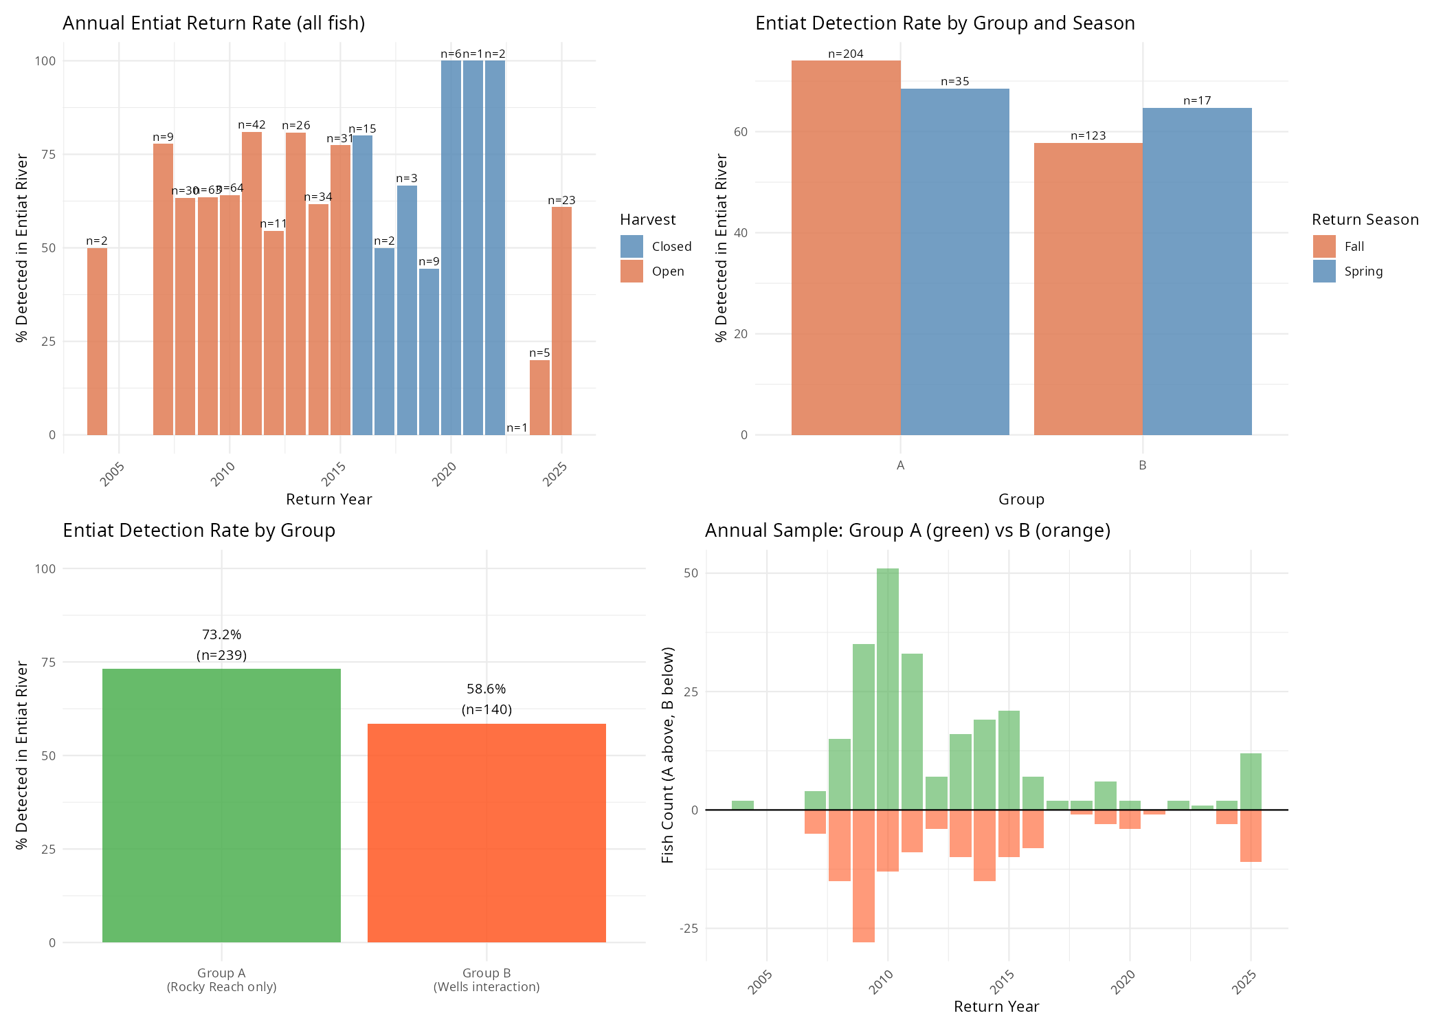

Figure 1. Data overview. Top left: Annual Entiat return rate, colored by harvest status (orange = open, blue = closed). Top right: Detection rate by group and return season. Bottom left: Overall detection rate by group. Bottom right: Annual sample size showing Group A (green, above axis) vs. Group B (orange, below axis).

Model Convergence
All three models achieved excellent convergence. The Gelman–Rubin diagnostic (R̂) was ≤1.01 for all parameters across all models, and bulk effective sample sizes exceeded 3,000 for all fixed effects. Trace plot inspection confirmed adequate chain mixing.

Model 1: Wells Interaction and Harvest Effects
Wells Dam interaction was the dominant and only credible predictor of Entiat River return probability. Group B fish had substantially lower odds of Entiat detection compared to Group A:

- β_wells = −0.642 (95% HDI: −1.085, −0.205)
- Odds Ratio = 0.53 — Group B fish had 47% lower odds of Entiat detection
- P(β < 0) = 0.997 — strong directional evidence for a negative effect

Annual harvest status (open vs. closed) showed no credible effect:

- β_harvest = −0.241 (95% HDI: −1.035, 0.520)
- Odds Ratio = 0.79; 95% HDI broadly spans 1.0
- P(β < 0) = 0.724 — insufficient evidence for a harvest effect

Year-level random effect standard deviation was σ ≈ 0.56, indicating substantial inter-annual variation in baseline Entiat return rates beyond what is explained by the fixed effects.

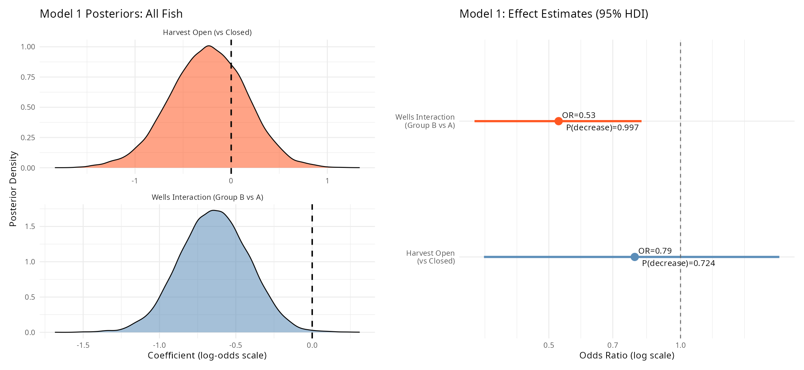

Figure 2. Model 1 results. Left: Posterior distributions for the Wells Interaction (blue, below) and Harvest Open (orange, above) coefficients. The Wells posterior is entirely below zero. Right: Odds ratio estimates with 95% HDI. The dashed vertical line at OR = 1.0 represents the null hypothesis.

Model 1b: Robustness to Spring Return Season
Including spring return season as an additional covariate had negligible effect on the Wells interaction estimate, confirming the result is not driven by differential detection efficiency:

- Model 1b β_wells = −0.645 (95% HDI: −1.083, −0.184), P(β < 0) = 0.998
- β_spring_return = −0.021 (95% HDI: −0.634, 0.594); OR = 0.98; P(β < 0) = 0.530

The spring season coefficient is essentially centered on zero. The two posteriors for the Wells interaction (with and without the season covariate) are nearly identical, as shown in Figure 3.

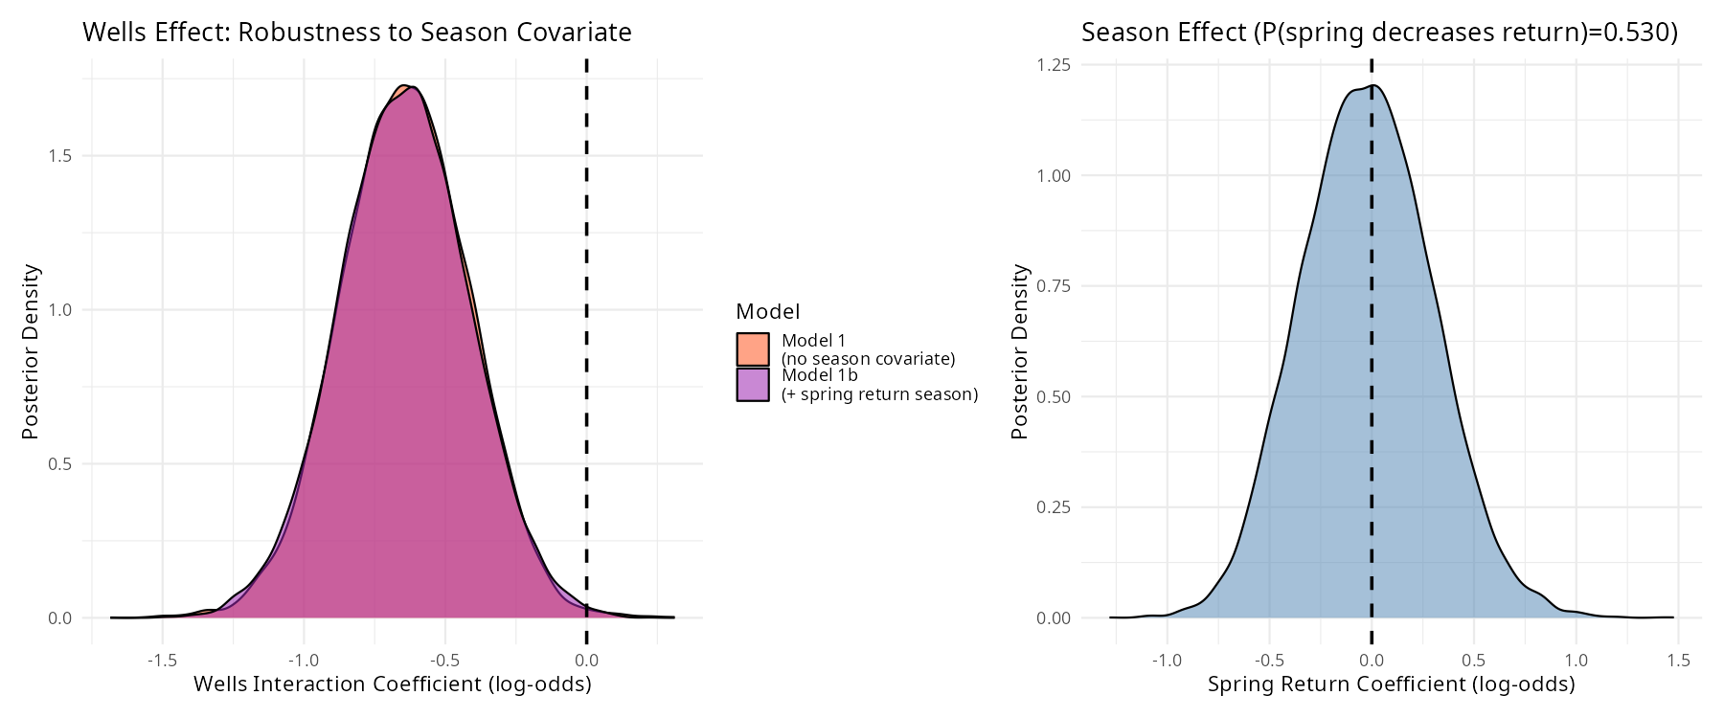

Figure 3. Robustness check for detection efficiency confounding. Left: Wells interaction posteriors from Model 1 (no season, orange) and Model 1b (with spring return covariate, purple) are nearly identical. Right: The spring return coefficient is centered on zero with P(decrease) = 0.530.

Detection-Corrected Models (Models 1c and 1d)
To formally account for imperfect ENL detection, we fitted a compound Bernoulli likelihood model: Y_i ∼ Bernoulli(θ_i × p_ENL_i), where θ_i = inv_logit(η_i) is the true return probability and p_ENL_i is per-fish ENL detection efficiency from the ENL gateway GAM (return date and year). Detection efficiencies ranged from 0.25 to 1.0 (mean = 0.860; 11 pre-operational returns set to p_ENL = 1.0).
The detection-corrected model (Model 1c) yielded β_wells = −0.790 (95% CI: −1.342, −0.260; OR = 0.45; P(β < 0) = 0.998), and Model 1d (adding spring season) yielded β_wells = −0.789 (95% CI: −1.344, −0.252; OR = 0.45; P(β < 0) = 0.998). Both are ∼0.15 log-odds units more negative than Model 1, because the compound likelihood infers that Group A's higher baseline return rate makes its undetected fish relatively more likely to be missed returners, slightly widening the inferred gap between groups. Both groups had virtually identical mean ENL detection efficiencies (Group A: 0.864; Group B: 0.864), so differential per-group detection probability is not a plausible source of bias. Convergence diagnostics were excellent (R̂ ≤ 1.001; bulk ESS > 12,000 for all fixed effects).
Detection-corrected return rates (Group A: ∼80%; Group B: ∼72%) are both higher than raw observed rates (73.2% and 58.6% respectively), reflecting ENL detection misses. We additionally estimated expected fates for the 53 undetected Group B fish using per-fish p_LMR and p_OKL from Methow and Okanogan gateway detection GAMs: ∼19.2 fish (36%) were expected to be true Entiat returners missed at ENL; ∼2.1 fish (4%) hidden strays missed at LMR or OKL; and ∼31.7 fish (60%) likely died, were harvested, or had other unobservable fates. The negligible hidden stray count confirms that misclassification of undetected strays is not driving the Wells interaction result.

Year Random Effects
Year-level random effects from Model 1 revealed substantial inter-annual variation in baseline Entiat return rates. The standard deviation of year effects (σ ≈ 0.56) confirms that factors not captured by the fixed predictors—potentially including river temperature, fish condition, and cohort effects—drive meaningful year-to-year variation. The hierarchical partial-pooling structure prevents any single anomalous year from unduly influencing the overall estimates.

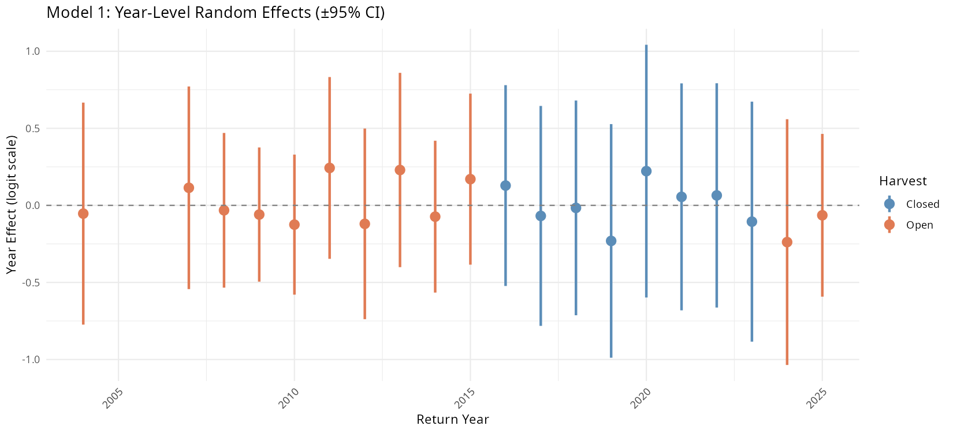

Figure 4. Year-level random effects from Model 1 with ±95% credible intervals, colored by harvest status (orange = open, blue = closed). Positive values indicate years with above-average Entiat return probability after accounting for group composition.

Model 2: Spill Effects Within Group B
Among Group B fish with available spill data (n = 116), no spill metric or harvest status credibly predicted Entiat return probability. All posteriors were broadly centered on zero with 95% HDIs spanning zero (Table 3; Figure 5):

- Spring Spill Hours (std): β = 0.301 (95% HDI: −0.215, 0.863), OR = 1.35, P(positive) = 0.864
- Fall Spill Hours (std): β = −0.045 (95% HDI: −0.544, 0.476), OR = 0.96, P(positive) = 0.426
- Harvest Open: β = −0.084 (95% HDI: −1.310, 1.137), OR = 0.92, P(positive) = 0.439

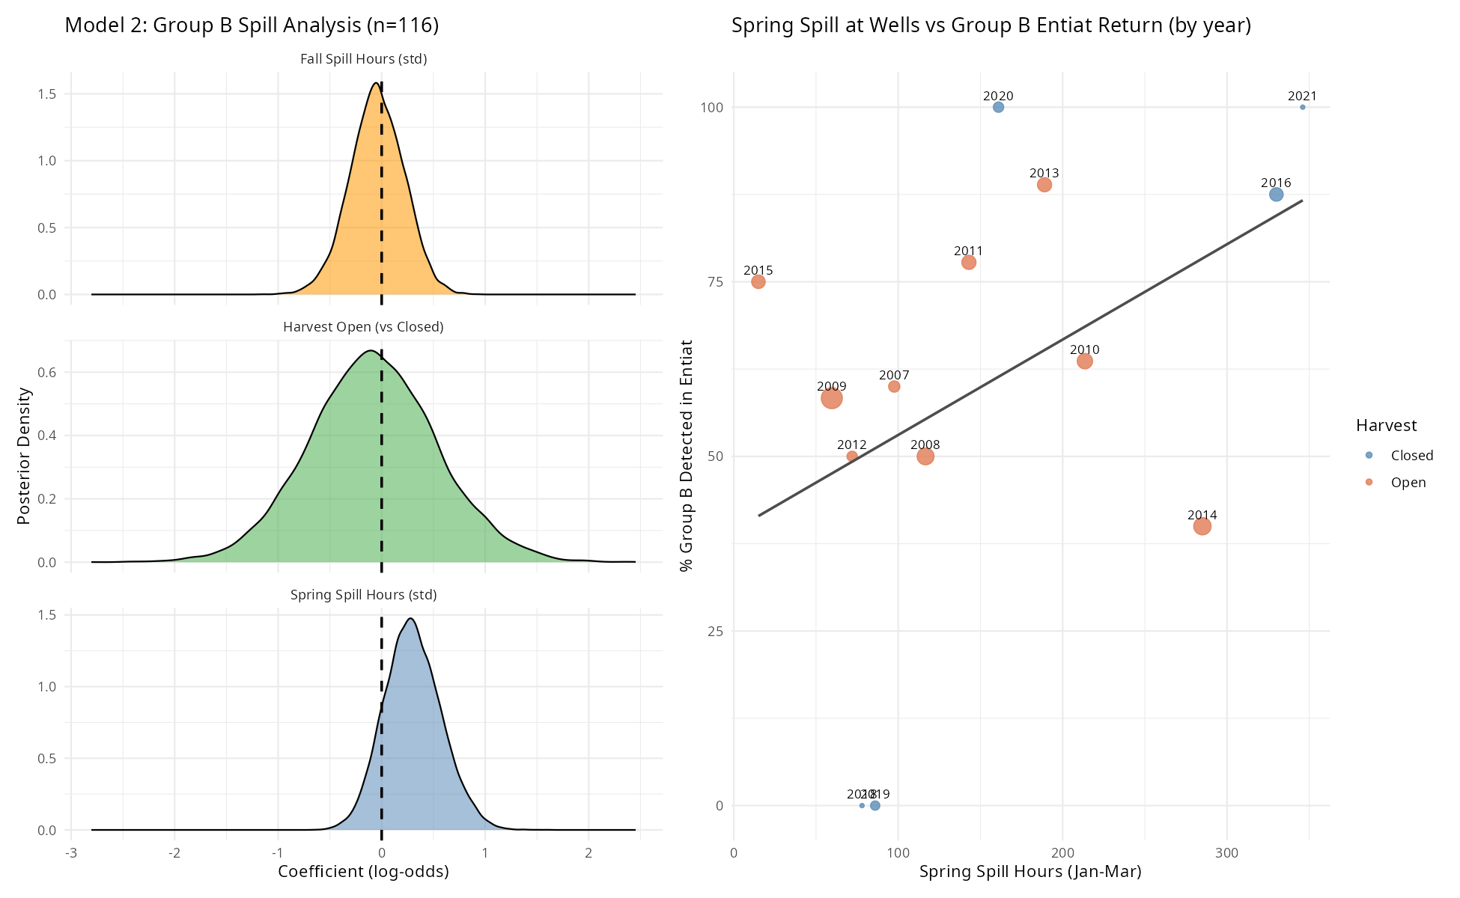

Figure 5. Model 2 results (Group B fish, n = 116). Left: Posterior distributions for spring spill hours (blue), fall spill hours (orange), and harvest open (green). All posteriors span zero. Right: Annual scatter of spring spill hours vs. % Group B fish detected in Entiat River, colored by harvest status.

Summary of All Model Results
Model / Parameter | β Mean | HDI Low | HDI High | Odds Ratio | P(decrease)
Model 1 — All Fish (n = 379)
Wells Interaction (Group B vs. A) | −0.642 | −1.085 | −0.205 | 0.53 | 0.997
Harvest Open (vs. Closed) | −0.241 | −1.035 | 0.520 | 0.79 | 0.724
Model 1b — All Fish + Season Covariate (n = 379)
Wells Interaction (Group B vs. A) | −0.645 | −1.083 | −0.184 | 0.52 | 0.998
Spring Return Season | −0.021 | −0.634 | 0.594 | 0.98 | 0.530
Model 2 — Group B Only, Spill Effects (n = 116)
Spring Spill Hours (standardized) | 0.301 | −0.215 | 0.863 | 1.35 | 0.136
Fall Spill Hours (standardized) | −0.045 | −0.544 | 0.476 | 0.96 | 0.574
Harvest Open (vs. Closed) | −0.084 | −1.310 | 1.137 | 0.92 | 0.561

Table 3. Posterior summaries for all models. β = log-odds coefficient (mean); HDI = 95% highest density interval; OR = exp(β); P(decrease) = posterior probability that β < 0. Bold P(decrease) values indicate strong directional evidence (≥0.95). Detection-corrected models (1c, 1d; see Results): β_wells = −0.790/−0.789, OR = 0.45, P(decrease) = 0.998.

Discussion

Wells Dam Interaction Substantially Reduces Entiat Return Probability
The primary finding of this analysis is that wild Entiat steelhead detected at Wells Dam had approximately half the odds of being subsequently detected in the Entiat River compared to fish that did not interact with Wells (OR = 0.53; P(β < 0) = 0.997). This effect is large, highly credible in a Bayesian sense, and consistent with the raw detection rate gap of 14.6 percentage points. The finding complements Murdoch et al. (2022), who estimated that roughly 40% of wild steelhead overshoots at Priest Rapids Dam fail to return downstream, and adds specificity by quantifying this reduction for wild Entiat fish at the uppermost fish-passage dam on the Columbia. Across our dataset, the Wells interaction effect translates to an estimated ~58 fewer Entiat detections among the 140 Group B fish than would be expected if they had the same return rate as Group A fish.

Detection Efficiency Does Not Explain the Group Gap
We considered the possibility that Group B fish return to the Entiat disproportionately in spring—when ENL detection efficiency is known to be lower due to elevated flows—and that the apparent group gap in detection rates is therefore artifactual. Three independent lines of evidence argue against this explanation. First, both groups had similar proportions of spring returners (~12–15%), so differential seasonal composition cannot explain the gap. Second, within-season analysis showed that the group gap was concentrated in fall returners (Group A 74.0% vs. Group B 57.7%), precisely the season when detection efficiency is high—not in spring where detection issues would be expected to appear. Third, adding spring return season as an explicit covariate in Model 1b produced a Wells interaction estimate virtually identical to Model 1 (β = −0.645 vs. −0.642), while the season coefficient itself was centered on zero (OR = 0.98; P(decrease) = 0.53), indicating no detectable independent effect of spring return timing on Entiat detection. Fourth, a compound Bernoulli likelihood model (Model 1c) incorporating per-fish ENL detection efficiency yielded a stronger Wells effect estimate (β = −0.790, OR = 0.45; P(β < 0) = 0.998) than the standard model, demonstrating that accounting for detection imperfection amplifies rather than attenuates the inferred effect. A hidden stray analysis estimated only ∼2.1 hidden strays (4% of 53 undetected Group B fish) missed at LMR or OKL, confirming that contamination with undetected non-natal spawners is negligible. Taken together, these four lines of evidence firmly establish that the group gap reflects a genuine behavioral or survival difference rather than a detection artifact.

Potential Mechanisms for Reduced Return
The mechanisms underlying the reduced Entiat return rate in Group B fish cannot be fully resolved from PIT-tag data alone, but several non-mutually exclusive explanations are plausible:

- Incomplete stray exclusion: Our criterion for excluding strays (last detected in Methow or Okanogan) captures confirmed non-natal spawners but misses fish that entered non-natal tributaries without detection or spawned in the mainstem reach between Rocky Reach and Wells. These fish would be misclassified as non-returning Group B fish.
- Downstream passage failure at Wells Dam: Fish attempting to fall back through Wells Dam may experience difficulty locating spill or surface bypass passage routes, or sustain injury during turbine or spillway passage. Fuchs and Caudill (2018) documented substantial discordance between PIT-based and radio-tag-based final fates of steelhead at Priest Rapids Dam, underscoring that PIT detection alone provides an incomplete picture of downstream passage outcomes.
- Overwinter or en-route mortality: Fish holding in the reservoir above Wells Dam or in transit between Wells and the Entiat may experience energetic depletion, thermal stress, predation, or other mortality. Keefer et al. (2008) documented variable overwinter survival of reservoir-holding steelhead populations, with some groups experiencing substantial loss.
- Detection gaps in the Entiat River: Group B fish not detected at ENL or other Entiat antennas may have entered the river but passed undetected. The ENL antenna has estimated miss rates of approximately 7.9% in fall and 24.3% in spring for fish detected elsewhere in the subbasin. Formal correction via compound Bernoulli likelihood (Model 1c) yielded OR = 0.45, indicating the true effect is larger than the naive estimate suggests.
- Harvest: Annual harvest status (open vs. closed years) had no credible effect in our model (OR = 0.79; 95% HDI spanning 1.0). This is consistent with the expectation that mark-selective fisheries targeting adipose-clipped hatchery fish would have limited direct mortality impact on unmarked wild individuals. Indirect effects—including disturbance, bycatch, and post-release stress—cannot be fully excluded.

Spill at Wells Dam Does Not Drive the Effect
Among Group B fish, neither spring nor fall spill hours at Wells Dam predicted Entiat return probability. All Model 2 coefficients were centered near zero with 95% HDIs broadly spanning zero. The null spill finding is consistent with the companion analysis of Entiat and Wenatchee River overshoot steelhead at Wells Dam (Kyger et al. 2026), which found no credible spill effect on downstream return probability in the broader mixed hatchery-wild dataset, and with Min et al. (2025), who found no benefit of late-winter spill on Entiat River return rates across a 20-year Columbia Basin dataset.

The consistency of the null spill result—across spring and fall windows, across standardized hours and volume metrics, and across both the within-group and all-fish analyses—suggests that spill operations at Wells Dam do not substantially alter the probability of wild Entiat steelhead returning to the Entiat River following an overshoot. Fish managers implementing targeted spill regimes at Wells Dam with the goal of improving wild Entiat return rates should not expect measurable benefits based on these data. This does not preclude possible effects of spill on other aspects of fish behavior such as migration timing, route selection, or passage injury rates, which were not examined here.

Year-to-Year Variation
The substantial year random effects (σ ≈ 0.56) indicate that factors not measured in this analysis drive meaningful inter-annual variation in Entiat return rates. Candidate drivers include Columbia River and Entiat River temperature conditions affecting fish holding behavior and physiology, mainstem flow conditions affecting dam passage efficiency, inter-annual variation in fish body condition entering the freshwater environment, and changes in Entiat River detection infrastructure over the study period. The hierarchical model structure appropriately accounts for this variation through partial pooling, preventing unusual years from unduly influencing the overall inference.

Conclusions
This study provides the first formal quantitative evaluation of the effect of Wells Dam overshoot on wild Entiat steelhead natal return probability. Wild Entiat steelhead that interact with Wells Dam have approximately half the odds of being subsequently detected in the Entiat River compared to fish that did not overshoot to Wells (OR = 0.53; P(β < 0) = 0.997). A compound-detection-likelihood model corroborated this finding (OR = 0.45; P(β < 0) = 0.998), and a hidden stray analysis found fewer than three hidden strays among 53 undetected Group B fish. This effect is therefore robust to both seasonal detection efficiency confounds and potential hidden straying, and consistent across dam operating conditions. Neither spill at Wells Dam nor annual harvest status explains the reduction. Additional telemetry-based research targeting wild Entiat-origin steelhead above Wells Dam would help discriminate among the biological mechanisms—stray behavior, passage mortality, overwinter attrition, and detection gaps—that collectively underlie the observed reduction in natal return.

References
Bürkner, P.-C. 2017. brms: An R package for Bayesian multilevel models using Stan. Journal of Statistical Software 80(1):1–28.
Bürkner, P.-C. 2018. Advanced Bayesian multilevel modeling with the R package brms. The R Journal 10(1):395–411.
Fuchs, H. L., and C. C. Caudill. 2018. Comparison of PIT tag and radio telemetry methods for estimating steelhead fate at Priest Rapids Dam. North American Journal of Fisheries Management 38:1138–1151.
Gelman, A., A. Jakulin, M. G. Pittau, and Y.-S. Su. 2008. A weakly informative default prior distribution for logistic and other regression models. Annals of Applied Statistics 2(4):1360–1383.
Keefer, M. L., and C. C. Caudill. 2014. Homing and straying by anadromous salmonids: a review of mechanisms and rates. Reviews in Fish Biology and Fisheries 24:333–368.
Keefer, M. L., C. T. Boggs, C. A. Peery, and C. C. Caudill. 2008. Overwintering distribution, behavior, and survival of adult summer steelhead: variability among Columbia River populations. North American Journal of Fisheries Management 28(1):81–96.
Kyger, C., A. Gingerich, K. Kendall, and T. Kahler. 2026. Effects of seasonal spill and harvest exposure on steelhead overshoot fate at Wells Dam. Public Utility District No. 1 of Douglas County, East Wenatchee, Washington.
Min, M. A., R. A. Buchanan, and M. D. Scheuerell. 2025. Modeling climate and hydropower influences on the movement decisions of an anadromous species. Global Change Biology 31:e70533.
Murdoch, A. R., C. O. Ochieng, and C. M. Moffett. 2022. Abundance and migration success of overshoot steelhead in the Upper Columbia River. North American Journal of Fisheries Management 42:1066–1079.
NOAA Fisheries. 2024. Upper Columbia River steelhead. https://www.fisheries.noaa.gov/west-coast/endangered-species-conservation/upper-columbia-river-steelhead
R Core Team. 2023. R: A language and environment for statistical computing. R Foundation for Statistical Computing, Vienna, Austria.
Richins, S. M., and J. R. Skalski. 2018. Steelhead overshoot and fallback rates in the Columbia–Snake River basin and the influence of hatchery and hydrosystem operations. North American Journal of Fisheries Management 38:1122–1137.
Thorson, J. T., and K. Kristensen. 2024. Hierarchical Bayesian models in fisheries stock assessment. ICES Journal of Marine Science 81:fsad199.
WDFW (Washington Department of Fish and Wildlife). 2024. Steelhead management in Columbia and Snake River basins. https://wdfw.wa.gov/fishing/management/columbia-river

